Creating Appium Script to check the battery percentage in Android phone Settings.

Install appium.

Install the uiautomator2 driver.

“appium” is the command to run the server. The appium runs on port 4723 by default.

Download Android Studio. Choose the latest version.

Check the terms and conditions and Choose Download.

This is how android studio interface looks like. Choose Virtual Device Manager.

There is an virtual device installed. Run the emulator.

The virtual device has opened.

Make sure to set the ANDROID_HOME path.

Create a new folder and open in terminal.

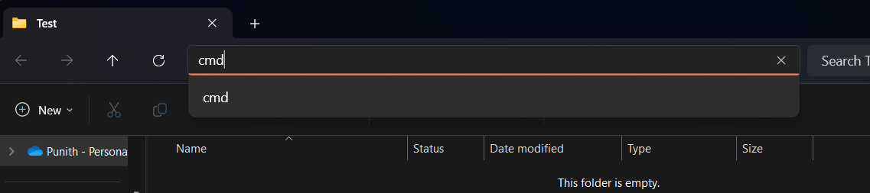

Use ‘npm init’ to initialize node into the folder.

Hit enter and the package.json has the dependencies created.

Install webdriverio package.

The node modules have been installed into folder.

This is the code used to run appium script and go to settings>battery and click on battery.

Make sure the appium is running.

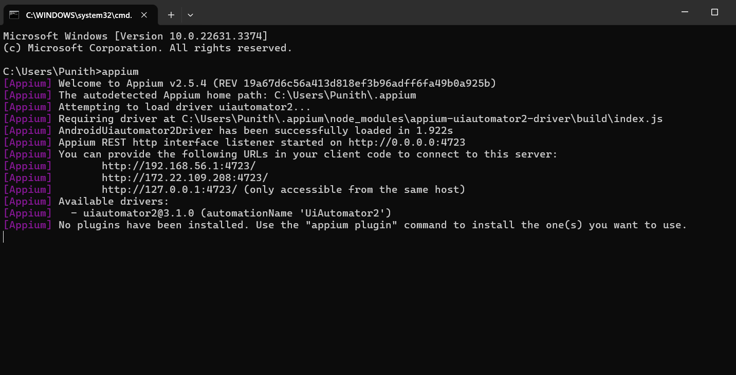

Enter ‘node test.js’ to execute the code.

Settings has opened and clicked on the Battery.

We can see it clicked and the battery of the virtual device shown up.

Video Link:

https://drive.google.com/file/d/1Kq0q7kaIfBxWjcIOLUvOKksTHeOIHrfc/view?usp=drive_link